# **PROGRAM**

A program is a set of instructions following the rules of the chosen language.

* Without programs, computers are useless.
* A program is like a recipe.
* It contains a list of ingredients (called variables) and a list of directions (called statements) that tells the computer what to do with the variables.
* A vocabulary and set of grammatical rules (syntax) for instructing a computer to perform specific tasks.
* Programming languages can be used to create computer programs.
* The term programming language usually refers to high-level languages, such as BASIC, C, C++, COBOL, FORTRAN, Ada, and Pascal.

You eventually need to convert your program into machine language so that the computer can understand it.

There are two ways to do this:

1. Compile the program
2. Interpret the program

## **Compiler**

Compile is to transform a program written in a highlevel programming language from source code into object code.

* This can be done by using a tool called compiler.
* A compiler reads the whole source code and translates it into a complete machine code program to perform the required tasks which is output as a new file.

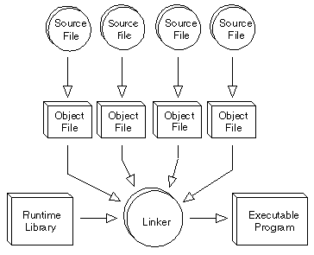

## **Interpreter**

Interpreter is a program that executes instructions written in a high-level language.

* An interpreter reads the source code one instruction or line at a time, converts this line into machine code and executes it.

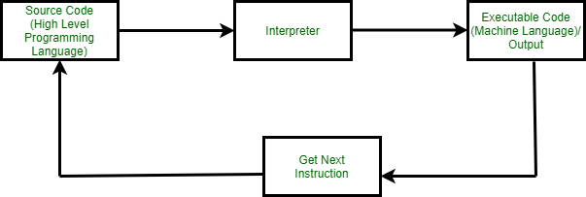

## Computer programming

is the process of writing, testing, debugging/troubleshooting, and maintaining the source code of computer programs.

* This source code is written in a programming language like C++, JAVA, Python etc.

## Computer Programmer

* A programmer is someone who writes computer program.
* Computer programmers write, test, and maintain programs or software that tell the computer what to do.

## Generations of Programming Language

* The first-generation languages, or 1GL, are lowlevel languages that are machine language.
* The second-generation languages, or 2GL, are also low-level languages that generally consist of assembly languages.
* The third-generation languages, or 3GL, are highlevel languages such as C.
* The fourth-generation languages, or 4GL, are languages that consist of statements similar to statements in a human language. Fourth generation languages are commonly used in database programming and scripts.
* The fifth-generation languages, or 5GL, are programming languages that contain visual tools to help develop a program. A good example of a fifth-generation language is Visual Basic.

## Types of Programming Languages

There are three types of programming language:

1. Machine language (Low-level language)
2. Assembly language (Low-level language)
3. High-level language

Low-level languages are closer to the language used by a computer, while high-level languages are closer to human languages.

### Machine Language

* + Machine language is a collection of binary digits or bits that the computer reads and interprets.
  + Machine languages are the only languages understood by computers.
  + While easily understood by computers, machine languages are almost impossible for humans to use because they consist entirely of numbers

### Assembly Language

The problem is that the computer doesn't understand the assembly code, so we need a way to convert it to machine code, which the computer does understand.

* + Assembly language programs are translated into machine language by a program called an assembler.

### High Level Language

* + High-level languages allow us to write computer code using instructions resembling everyday spoken language (for example: print, if, while) which are then translated into machine language to be executed.
  + Programs written in a high-level language need to be translated into machine language before they can be executed.
  + Some programming languages use a compiler to perform this translation and others use an interpreter.

We program the code in high-level languages and following are the top languages.

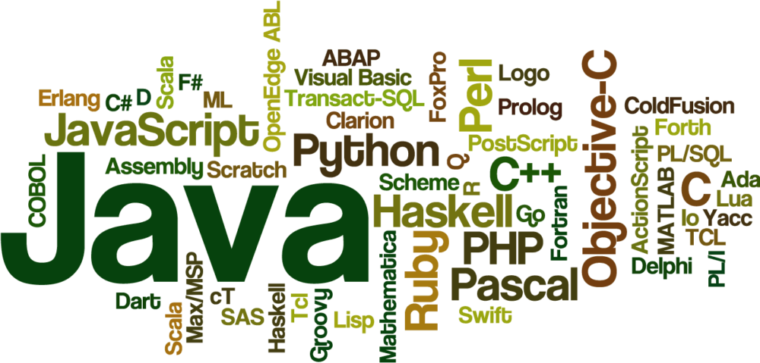

#### C

* + Developed by Dennis Ritchie at Bell Labs in the mid-1970s.
  + C is much closer to assembly language than are most other high-level languages.
  + The first major program written in C was the UNIX operating system.
  + The low-level nature of C, however, can make the language difficult to use for some types of applications.

#### C++

* + A high-level programming language developed by Bjarne Stroustrup at Bell Labs.
  + C++ adds object-oriented features to its predecessor, C.
  + C++ is one of the most popular programming language for graphical applications, such as those that run in Windows and Macintosh environments.

#### Pascal

* + A high-level programming language developed by Niklaus Wirth in the late 1960s.
  + The language is named after Blaise Pascal, a seventeenth-century French mathematician who constructed one of the first mechanical adding machines.
  + It is a popular teaching language.

#### Java

* + A high-level programming language developed by Sun Microsystems.
  + Java was originally called OAK and was designed for handheld devices and set-top boxes.
  + Oak was unsuccessful so in 1995 Sun changed the name to Java and modified the language to take advantage of the burgeoning World Wide Web.
  + Java is a general-purpose programming language with a number of features that make the language well suited for use on the World Wide Web.